Enroll in the VPP program, click here for those instructions.

1. Contact [support@precyseuniversity.com](mailto:support@precyseuniversity.com) with the email address used to register for VPP so we can make sure you are setup to access our app
2. Once enrolled login to your VPP store: [http://vpp.itunes.apple.com](http://vpp.itunes.apple.com/)
3. Click the link to the Business Store
4. Enter “Precyse University” into the Search

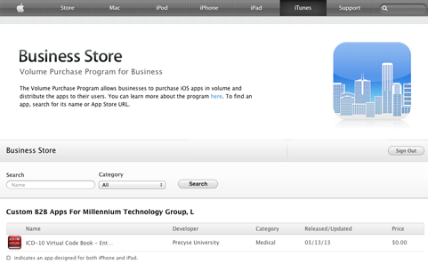

1. Click the ICD-10 Virtual Codebook – Enterprise Edition icon
2. Enter the quantity of codes you need and then click the Buy icon

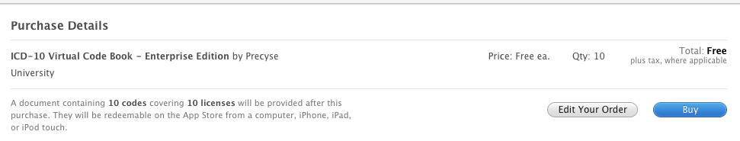

1. The registered email will receive a spreadsheet (you can also download the sheet from this site) with codes based on the number you requested
2. You can use the now distribute these codes by your users clicking on the link provided in the spreadsheet on the Apple device or provide the user can enter the code provided after clicking the Redeem button in the App Store on the device.